RESOLUTION NO.__________

RE: CERTIFICATE OF APPROPRIATENESS UNDER THE

PROVISIONS OF THE ACT OF THE PENNSYLVANIA

LEGISLATURE 1961, JUNE 13, P.L. 282 (53

SECTION 8004) AND BETHLEHEM ORDINANCE NO.

3952 AS AMENDED.

WHEREAS, it is proposed to install a signage plaque at the main entrance at 301 Broadway.

NOW, THEREFORE, BE IT RESOLVED by the Council of the City of Bethlehem that a Certificate of Appropriateness is hereby granted for the work.

Sponsored by: (s)

(s)

ADOPTED BY COUNCIL THIS DAY OF

(s)

President of Council

ATTEST:

(s)

City Clerk

HISTORIC CONSERVATION COMMISSION

CASE # 587– It is proposed to install a signage plaque at the main entrance at 301 Broadway

OWNER/APPLICANT: Sycamore Hill Farm Development / Larry Eighmy

The Commission upon motion by Mr. Evans seconded by Mr. Lader adopted the proposal that City Council issue a Certificate of Appropriateness for the proposed work described herein:

1. The proposal to install a signage plaque at the main entrance at 301 Broadway was represented by Larry Eighmy and Traci Mindler.
2. A 12” x 18” signage plaque will be installed at the main entrance facing Broadway, replacing the existing plaque on the east side of the entrance.
3. The new plaque will have a brown background with “Lehigh University, Communications & Public Affairs”, and Lehigh’s seal in white, serif style lettering.
4. The existing mounting holes will be re-used.
5. The proposed motion was unanimously approved.

CU: cu

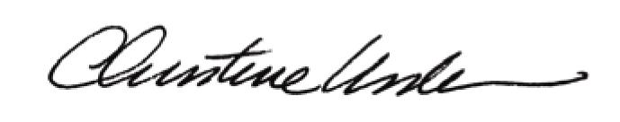

By:

Date of Meeting: May 16, 2016 Title: Historic Officer